Department User Quick Start Guide
https://secure42.ipayment.com/SIU/ipayment.htm?app=pos
Important!
Please insure that your popup blocker is not blocking the Ipay sites.
To turn off popup blocker, follow these steps
__________________________________________________________________________________________________
For Internet Explorer
Click the Gear icon at the top right of Internet Explorer and click Internet Options. Click the Privacy tab, uncheck Turn on Pop-up Blocker and then click OK.
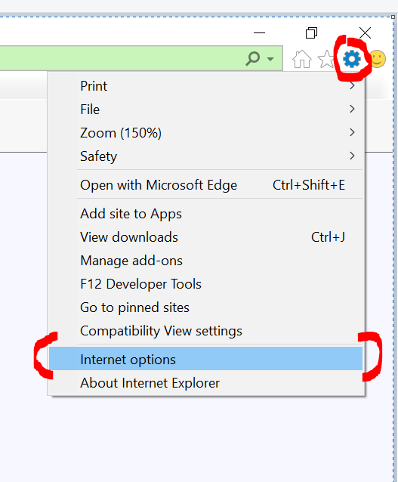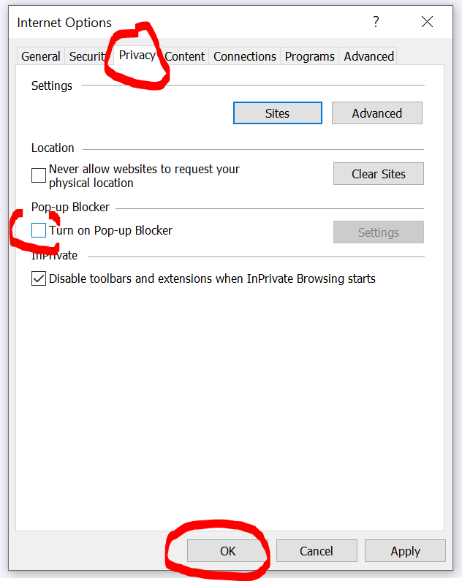
__________________________________________________________________________________________________
For Firefox
Click the 3 bars icon at the top right of Firefox and click options. Click Privacy & Security then scroll down and find Block pop-up windows and uncheck that box. Click X to close the settings tab.
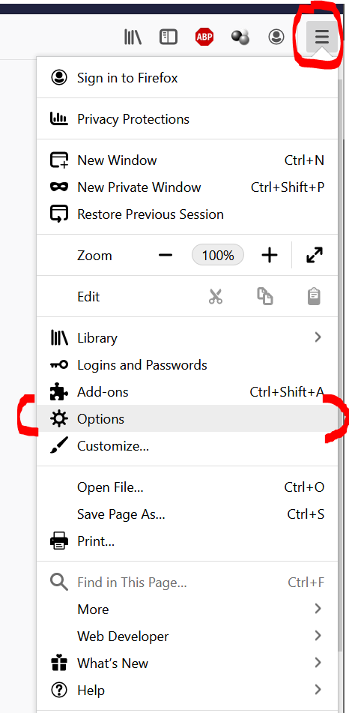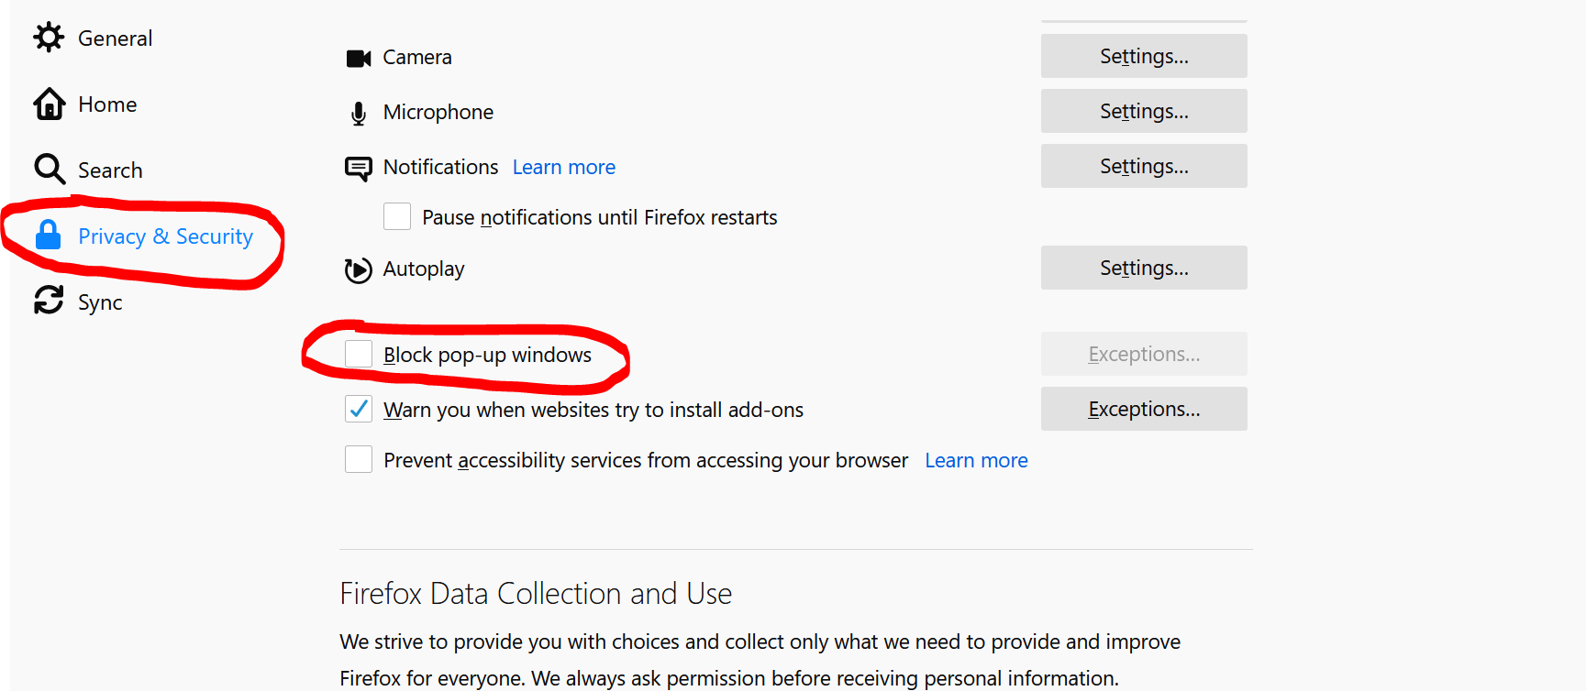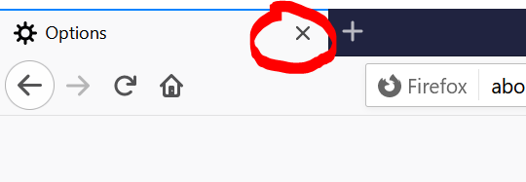
__________________________________________________________________________________________________
For Google Chrome
Click on the menu button at the right of the address bar 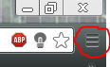 and Click Settings
At the bottom of the settings screen click show advanced settings.
Under Privacy category, click Site Settings. Then under Permissions category, click Pop-ups and redirects. Click the switch to Allow popups. Click X on the tab to exit.
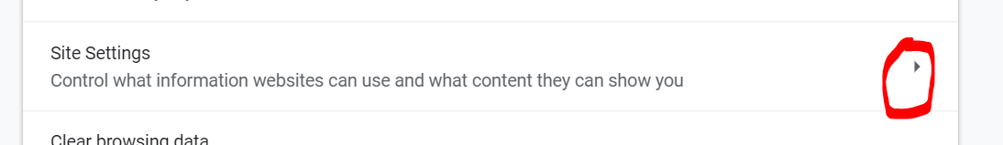
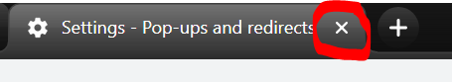

Ipay Usage Guide
- By default the temp password is welcome12. Username is in my email. If you have already logged into the system and set a password, the password may be expired. If so Please give us a call. Once you type your username and welcome12, the password expiration box will show. After clicking OK, you will be taken to the change password box. Here you will type your username, welcome12 then enter a new password of your own. It must be 8 characters long with 2 numbers. It is case sensitive. If you have problems logging in or need password assistance, contact Kevin Mayberry at 453-5228, mayberry@siu.edu
Make sure you are on the Cashiering section. If not, click the person with cash register at the top.

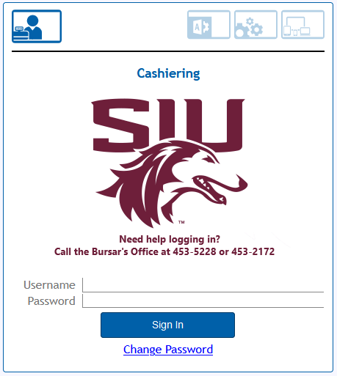
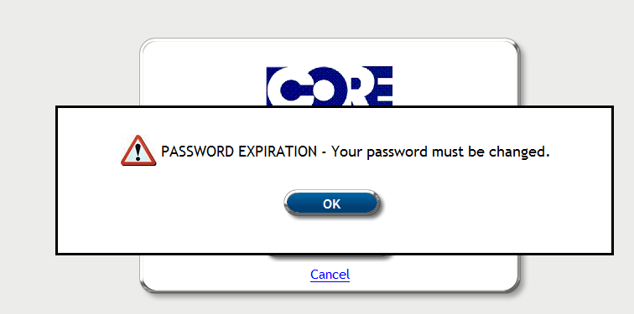
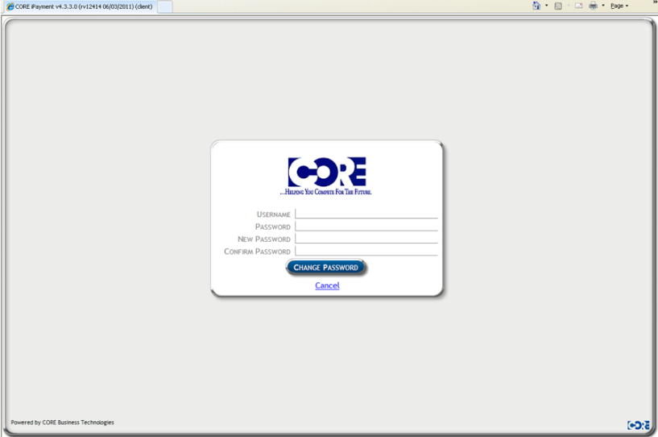
- After logging in, the user will be brought to a screen to where they can create a new pay file or complete an existing one with file management. By default, the effective date will auto fill with today’s date. This should stay as it is. Description will auto fill with today’s date. It will be in a date format.

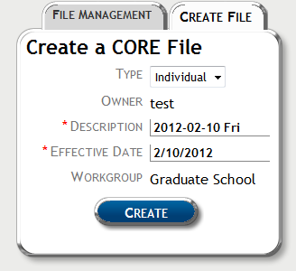

- Once you have created a pay file, you will see the tab called Financial. Click the arrow button on the transaction line you want to create a deposit for.
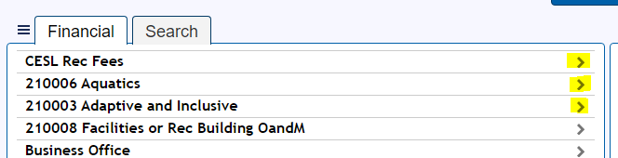
- The next step is to add amounts in the type of allocation you wish to deposit. Once the amount is entered, you can tab to the next field or click on any other field. The GL line selected field will automatically check.
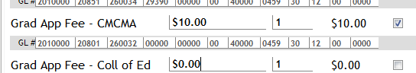
- When you are done adding your amounts, you must complete the comment field at the bottom of the page. You can name this anything you like. This field prints out on your confirmation sheet as well as the fiscal officer’s month end reports. Click continue to proceed to the next step.
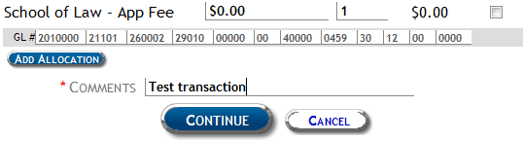

- You will note the Tender Due at the bottom left box. You can then select the tender type you wish to deposit. In this demo we have selected Cash, but you can have more than 1 tender per deposit. Just enter the amount in cash then select check for the remaining amount due. Note: Checks have to have a description entered. Example- name on check, check number ext.
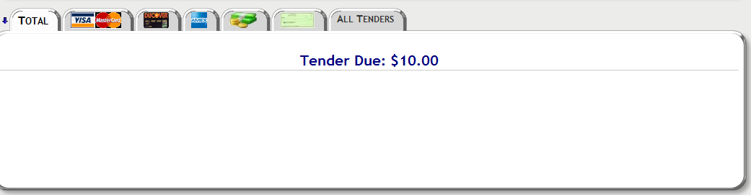
Click OK after entering your tender.
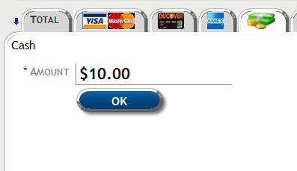
- Once you have tendered the transaction, the system will prompt you to print a Receipt Page. Print 1 for your records and 1 for the Bursar’s Office.
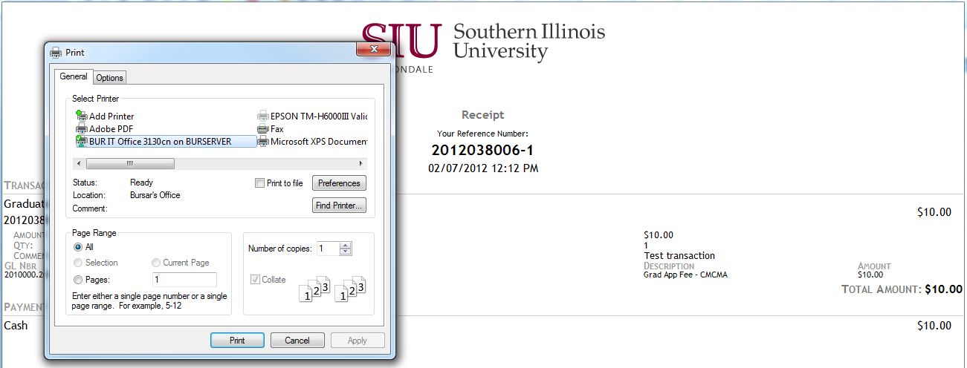

- After printing your receipt, you can close the print popup window. You will be taken back to your pay file page. The last step is to Auto Balance the pay file. Click the blue Auto Balance button. “Do not click Balance!”
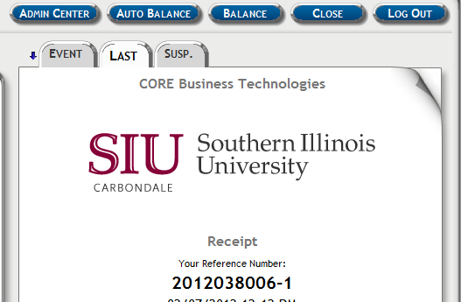
- After clicking Auto Balance, you will be prompted with the summary page that says File is balanced! Click OK. You can choose to print for your record or Exit the pay file. This concludes your ipay file.
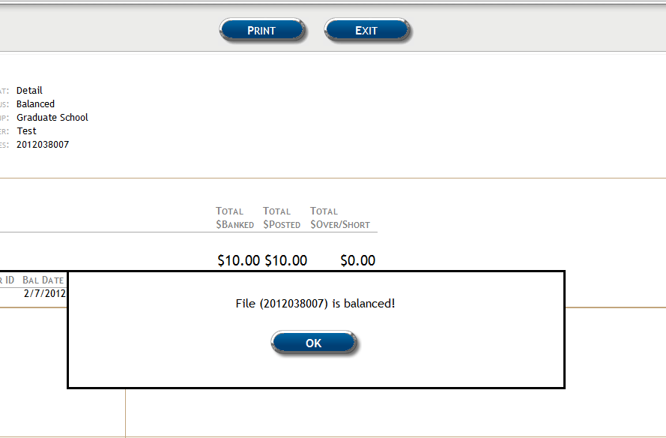
- Send 1 copy of the reciept with cash and checks to the Bursar’s Office to be processed.

